**Research Puzzle Ideas:**

1. 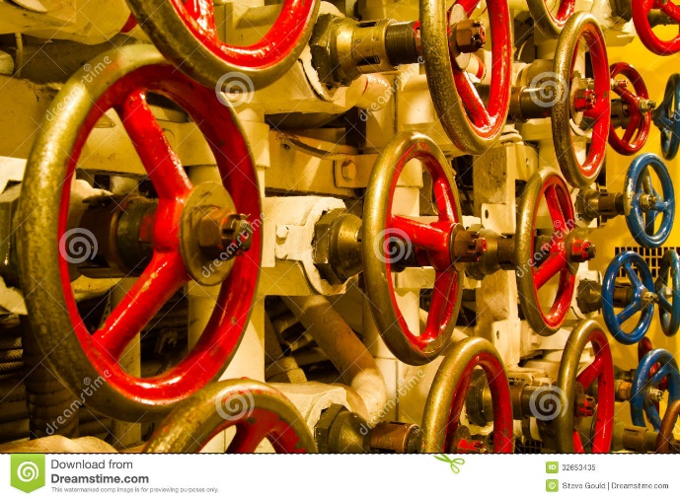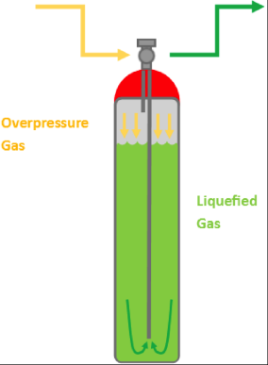Pressure level Puzzle:  
   Two gas cylinders, each one you have to rotate the valve, this has to be down where the pressure has to be at as certain level. If this puzzle fails, it will explode causing the player to lose all the sanity and sends the game in a game over state.
2. 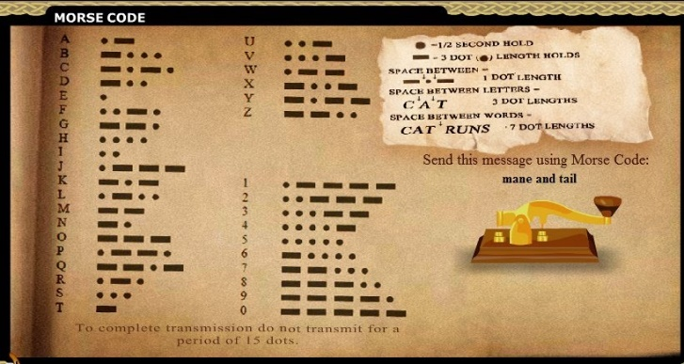Communication puzzle:

This puzzle is a morse code message this puzzle could be used to communicate to locations to get you off the island in the late game, or this puzzle could be used to translate old messages which provides the player with information about what things that carried out in the facility.

((Morse Code - Horse Isle 2 Help, 2020)

1. 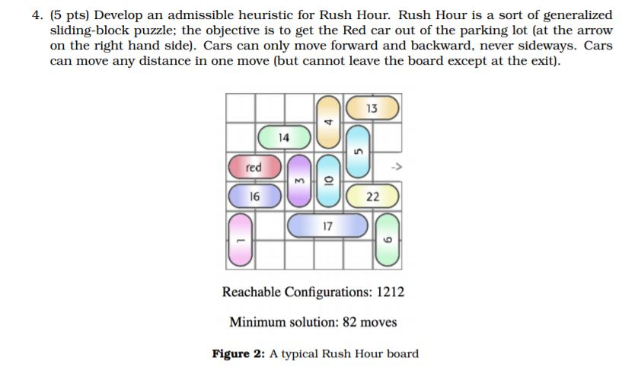Reboot generator puzzle:

This puzzle sees a broken object inside the generator such as a loose screw, the objective is to more parts of the generator to different locations to provide space for the broken part to come out of the generator.

As seen beside is the generalized idea of the generator puzzle it is the same idea as a sliding block puzzle.

(Questions: Develop An Admissible Heuristic For Rush hour. Rush hour sort generalized sliding block puzzle, 2020)

1. Connect/cut wire Puzzle:

First of all, the player needs to unscrew the panel off the wires and then the player can either cut wires which may be done to open certain doors or even connect wires to fix equipment or turn on lights. Wire puzzles can have a basic complexity but can get as complex as needed.

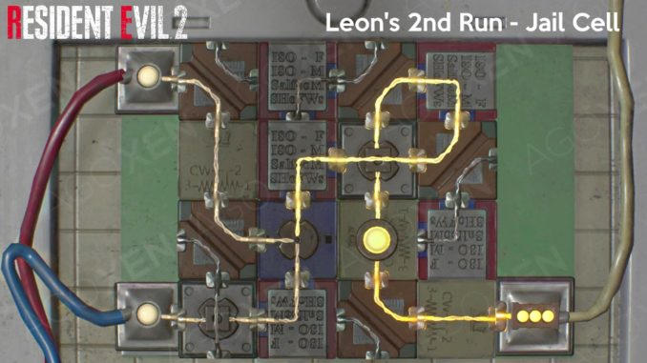

(Resident Evil 2 (2019) Puzzle Solutions Guide | AGOXEN, 2020)

As shown by the image, it provides a complex way of connecting wires. This can be where you rotate squares making sure that the circuits connect perfectly.

Having these puzzle multiple times could be a way of opening doors that lock in some reason, where if you are stuck inside a room and need to get out to carry on with the game.

1. Code Cracker:

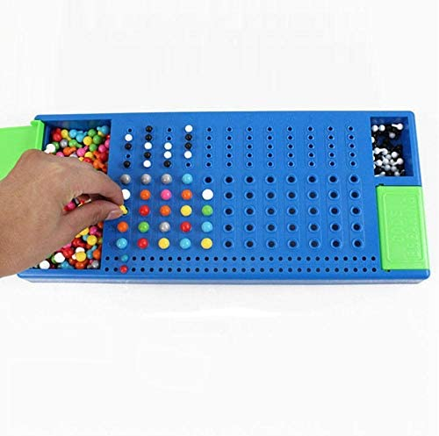This puzzle/game is about having a limited amount of tries at guess the correct code, these could be colours, numbers or anything. The player is provided with 12 guesses and depending on the colour and location of them it will provide a colour code of black and white above the guesses.

* White means the colour is located in the wrong space in the code
* Black means the colour is correct and in the correct space in the code
* No colour means that the colour in the guess is not in the code and not in the correct position.

Here is an example:

The code is Orange, Red, Yellow, pink

The players guess Red, Brown, Pink, blue

This would mean the colour code would be White, No colour, White, No colour

This is because in the code, colour red is in the code just not in the correct order, the same as pink.

**Bibliography**

2020. *Questions: Develop An Admissible Heuristic For Rush Hour. Rush Hour Sort Generalized Sliding Block Puzzle*. [online] Available at: <https://www.chegg.com/homework-help/questions-and-answers/develop-admissible-heuristic-rush-hour-rush-hour-sort-generalized-sliding-block-puzzle-obj-q41847390> [Accessed 12 November 2020].

AGOXEN. 2020. *Resident Evil 2 (2019) Puzzle Solutions Guide | AGOXEN*. [online] Available at: <https://www.agoxen.com/resident-evil-2-2019-puzzle-solutions-guide/> [Accessed 12 November 2020].

Sites.google.com. 2020. *Morse Code - Horse Isle 2 Help*. [online] Available at: <https://sites.google.com/site/horseisle2/mini-games/morse-code> [Accessed 12 November 2020].

<https://www.cacgas.com.au/blog/bid/404309/specialty-gas-valves-connectors-used-with-high-pressure-gas-cylinders>

<https://www.dreamstime.com/royalty-free-stock-photo-valve-wheels-inside-old-submarine-wall-full-red-gold-russian-image32653435>